Sketchup Plugin

The Idea for the plugin is to be able to do 2D technical drawings which are vectors based – but will also have textures inside the drawing as well and may be Pictures / these could be Jpeg or PNG. What I need is to be able to do the drawings inside SketchUp but then export the drawing to a good Quality PDF – which is the same as AutoCAD. An example of this will be sent.

in order for this to happen I will require the following to be included in the plugin:

- Be able to select the paper size – these will be templates already made and ready to be used – so I will need to be able to make the templates in sketchup and save them in the folder /section ready for me to select the size I require, paper sizes to be available: The information in the template needs to be editable

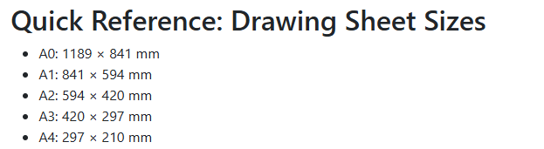
- Scaling will be required – this will be the same process as you did in AutoCAD – but what I would like is to be able to take dimensions after it is scaled – the dimensions would reflect the real-life dimension (please ask for clarification if you’re not sure). The scaling required would be all the regular scaling ratios but ideally be able to select be spoke scaling as well.

- Text Tool

The text would need to work where I click on textbox draw the area where the text will be written and then write the text in the box – exactly the same as in word. – I should be able to select the font, if I want it in bold and in what color - I would also need to be able to select the select and change the color and size of it in case I need change anything in the drawing.

Included in the text tool I would like to be able to put arrows in the drawing space to label items. I should be able to type sentences and paragraphs as be the word principles.

- I would like this be usable in any version of SketchUp if possible if there are any restrictions on this please let me know.
- When importing pictures /jpegs etc. into SketchUp it appears to loose some quality – can you please check on this and advise on a work around on this – the issue is if Quality is lost by inserting it into SketchUp then when exporting it to PDF it will be even worse.

- Exporting the Drawing to PDF

The idea is to export the drawing space only this will be paper space/template after I have scaled and edited the drawings etc. The Quality of the PDF needs to be as extremely good for vector and texture. When enlarging the PDF the Quality of the drawing needs to remain – I will send over an example of the PDF and texture I will be using. Below is an example of the texture.


- Bring drawing to the front or back
In AutoCAD there is a option to bring the item to the front of set it back please include this as well. I’m guessing that bring something to the front might require it to be brought forward a few MM and the same for setting something to the back.

- 2D lock

The 2D lock means you are only allowed to draw in the 2 axis views shown in SketchUp when looking from above.

You should be able to move the screen in the direction of the red and green axis only – this would mean that anything drawn would be on the same plane/level which mean using the bring forward or step back tool for objects or groups would be more accurate.

Just for clarity the 2D lock tool does not mean to lock the screen completely but to just stop SketchUp rotating 3D – so you are drawing the same as per CAD when drafting in 2D

